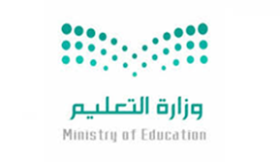
Kingdom of Saudi Arabia
Ministry of Education Al Roumi school
ـــــــــــــــــــــــــــــــــــــــــــــــــــــــــــــــــــــــــــــــــــــــــــــــ
International week of space report

In the name of Allah, most gracious , most merciful
This week began on 4-10-2018
In our school we activated this occasion by the following
Show some videos about space*
School broadcasting.*
*Have students draw and paint in extracurricular activity.
We made mini gallery to show students' works. *

School principal Teacher
Wedad Muhammad Hnan Abdullah

